First steps in pyspread


by Martin Manns 2011

About this document
This document shall provide a quick overview over pyspread.

What is pyspread?
Pyspread is a spreadsheet application that computes Python expressions in its cells. It is written in the programming language Python.
The core mission of pyspread is to make coding in a spreadsheet as pythonic as possible. Cell functions that are known from conventional spreadsheets such as Excel™, gnumeric or OpenOffice.org Calc are not supported. Instead Python expressions are entered into the spreadsheet cells. Each cell returns a Python object. These objects can represent anything including lists or matrices.
At least basic knowledge of Python is required to effectively use pyspread.
Pyspread provides a three dimensional grid that can comprise millions of rows, columns and tables. However currently, a dictionary is used for storing all grid data. Therefore, tables with many filled cells may require considerable amounts of RAM.

Current limitations
External libraries such as matplotlib that set states in several steps may be unusable or hard to use because cell execution order is not guaranteed. They should be used from within a macro.
- There is no chart creation GUI interface.
- There is no cell auto-fill functionality.
- Cell execution cannot be interrupted or terminated if slow and therefore may block pyspread.
- Toolbar positions are not saved in the config file.
- Cycle detection can be tricked. Cell results can be unstable if cyclic dependencies are introduced.
- Cell attributes can only be set in the toolbar but not in the menubar

Installation

Requirements
Linux and *nix platforms with GTK+ support.
Dependencies
- Python >=2.4 <3.0
- numpy >=1.1.0
- wxPython >=2.8.10.1 (unicode version required).
- PyMe >=0.8.1

Highly recommended for full functionality
- gmpy >=1.1.0
- rpy >=1.0.3.

Installation from source
- Untar the source package into a directory of your choice:
tar xzvf pyspread-<version number>.tar.gz
- Run:
python setup.py install

Installation from .deb package
Download the deb package and type
dpkg -i <package name>

The pyspread workplace

Starting and quitting pyspread
Type
$ pyspread
from the command prompt.
You can quit pyspread by closing the main window or by selecting File → Quit from the menu.

Pyspread main window
The main window consists of the title bar, the menu, toolbars, the entry line, the table selector, the grid and a status bar (see Figure 1).
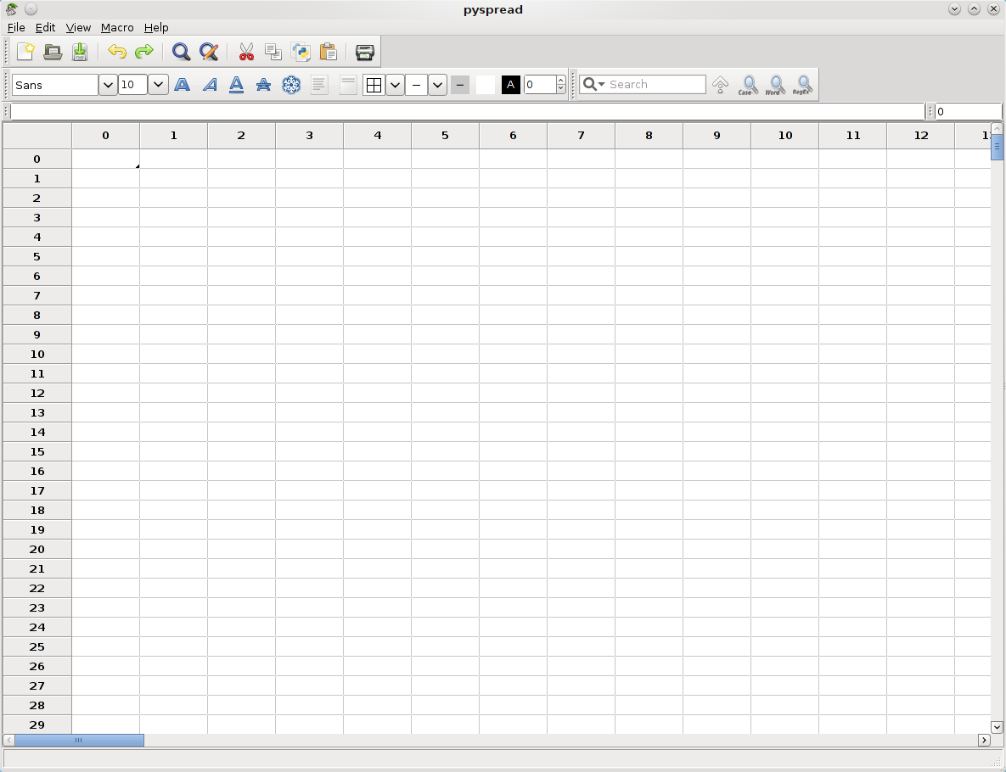Figure 1: Pyspread main window

Using the menus
There are two menus in pyspread: The main menu and the context menu. The main menu is visible above the tool bars. The context menu is accessible by right-clicking on the grid.
The main menu makes all pyspread functions but cell formatting available. The latter is only available via tool bar and not yet integrated into the main menu.
All options in the context menu are available from the main menu as well.

Using dialogs
Pyspread uses both modal and non-modal dialogs. Modal dialogs block further usage of pyspread while open while non-modal dialogs allow continuing the usage of the main program. Non modal dialogs are:
- The Search & Replace dialog

Basic preferences
Pyspread stores its configuration in a file ~/.pyspreadrc
This file is created when first starting pyspread. Removing it resets configuration.
Initial configuration can be viewed in pyspread/src/config.py

Basic concepts

3D grid
Pyspread features only one grid at a time. However, this grid is 3D, i. e. there are rows, columns and tables in the grid. The main difference to common spreadsheets is that each dimension is considered equal. Therefore, deleting a row deletes this row in all(!) tables.
There are no sheets at the moment, in which row operations do not affect other tabs. Sheet functionality may become part of future releases.

Everything is accessible
All parts of pyspread are written in Python. Therefore all objects can be accessed from within each cell. This is also the case for external modules.
There are 4 convenient “magic” objects, which are merely syntactic sugar: S, X, Y and Z.
S is the grid data object. It is ultimately based on a dict. However, it consists of several layers on top. When indexing or slicing, it behaves similarly to a 3D numpy-array that returns result objects. When calling it (like a function) with a 3 tuple, it returns the cell code.
X, Y and Z represent the current cell coordinates. When copied to another cell, these coordinates change accordingly. This approach allows relative addressing by adding the relative coordinates to X, Y or Z. Therefore, no special relative addressing methods are needed.
External modules are accessible from each cell. Unfortunately, Python’s convenient import syntax
from xx import yy
is no expression. Therefore, the expression
xx = __import__(“xx”)
has to be used.

Python code as cell language
Pyspread uses Python expressions in each cell. This is similar to typing expressions into the Python shell. However, there is no guaranteed execution order. Furthermore, all results are accessible from each other cell.
Variable assignment works only once in each cell. Therefore
a = b = 2
is invalid in pyspread.

Trust based security
Since Python expressions are evaluated in pyspread, a spreadsheet is as powerful as any program. Therefore, it could harm the system or even send confidential data to third persons over the Internet. Even though this is basically the case for all office applications, the easy access to such behavior makes precautions necessary. The idea in pyspread is that you – the user – are trustworthy and no-one else. If you save a file then a signature is saved with it (suffix .pys.sig). Only you can re-open the file directly. If anyone else opens the file, it is displayed in safe mode, i. e. each cell displays the cell code and no cell code is evaluated. The user can approve the file, after which the cell code is evaluated. When the user then saves the file, it is newly signed. Then it can be re-opened without safe mode.
An intended side-effect of this approach is that when two users open the file on a network share, the signature file of one user is not recognized by the other, which makes re-approval necessary.
Technically, signing is done with GPG. When starting pyspread the first time as a user, a new GPG key pair (name pyspred_<user_id>) is created, which is then used for signing files.

Common spreadsheet tasks

Moving in the spreadsheet
Movement in the grid can be achieved by:
- Scrolling with the scrollbars
- Selecting “View → Go to cell” from the main menu
- Moving the grid cursor with the arrow keys
- Clicking on a cell
- Accessing the grid API (advanced)
This covers row and column movement.
Table movement is described in the next paragraph

Switching tables
Tables can be switched by changing the number in the table switch textbox that is situated right of the entry line directly above the grid.
This can be achieved by either typing in a table number or by moving the mouse over the table switch textbox and then scrolling with the mouse wheel.

Entering data
Data is entered into the grid cells by selecting a cell and then typing the text. The text can also be entered into the text-entry line. The text is accepted and evaluated when <Enter> is pressed or when a new cell is selected. Note that <Enter> does not work from withing the text entry line.

Changing and deleting cell content
In order to change cell content double-click on the cell or select the cell and edit the text in the entry line.
A cell can be deleted by selecting it and pressing <Del>. This also works for selections.

Selecting cells
Cells can be selected by the following actions:
- Keeping the left mouse button pressed while over cells selects a block
- Pressing <Ctrl> when left-clicking on cells selects these cells individually
- Clicking on row or column labels selects all cells of a row or column
- Clocking on the top-left label of the grid or pressing <Ctrl> + A selects all grid cells of the current table
Only cells of the current table can be selected at any time. Switching tables switches cell selections to the new table, i. e. the same cells in the new table are selected and no cells of the old table are selected.

Copy and Paste operations
Copying and pasting can be done from within cells, which copies the text.
Furthermore, cells can be copied and pasted. If more than one cell is selected, the copied set consists of the bounding box of the marked cells, i. e. the smallest box, in which all cells are situated. Cells that are not selected in that box are copied as if they were empty. When pasting cells, these empty cells are pasted as well as the filled cells. That means that an unselected cell in a marked area will be pasted as empty cell.
The format of cells that are copied is tab separated Unicode.
When copying cells with <Ctrl> + C, the cell code is copied. There is a second type of copy <Shift> + <Ctrl> + C, which copies string representation of the results. This is useful, if for exapmle the result shall be copied into an external application.

Undoing work steps

Creating an empty spreadsheet

Loading and saving a spreadsheet

CSV data import and export

Printing

Finding and replacing cell code

Sorting
Sorting rows of column 0 in table 0:
[S.__setitem__((i, 0, 0), repr(val)) for i, val in enumerate(reversed(sorted(S[:,0,0])))]

Working with formulas

Python expressions

Result object

Example: Using sum

Frozen cells

Absolute cell access

Absolute cell addresses can be inserted into cell code with <Ctrl> + <LeftClick> on a cell.

Relative cell access

Relative cell addresses can be inserted into cell code with <Shift> + <Ctrl> + <LeftClick> on a cell.

Assigning variables

Macros

Module import

Cyclic references

Result stability

Error handling

Using help

Tutorial access

In-code documentation

Grid layout

Formatting basics

Fonts and font attributes

Text alignment, justification and rotation

Border and background color

Row height and column width

Insertion and deletion of rows and columns

pyspread and security

More than your average spreadsheet

Dangers of using pyspread

Security benefits and risks from save file signatures

Charts

Charts with matplotlib

Charts with rpy2

Charts with pychart

Advanced topics

Drawing cell content with a cell formula

Handling large amounts of data

Substituting pivot tables

